Supplementary materials

**Figure S1:** Study site and location of clinics that were used for recruitment.

**Figure S2:** GPS reading errors in stationary devices.

We conducted field tests of GPS device error under stationary conditions (Figure S2). These tests consisted of placing GPS loggers in stationary locations (tied to a bamboo pole, on a shelf in a house), plotting the points from the device over a period of one week, and measuring the geographic distribution of those points from their geographic centre. Devices were placed inside bags, as this would also be likely for carriage/storage by participants.

The mean locational error recordings was larger for the in-doors device. Most erroneous points were within 50 meters of the house. However, a few points were far outside of this range (inset map on bottom left). The maximum distance away from the centre for any of the erroneous points was over 3km away. Only one reading was recorded at this distance and the next reading (30 minutes later) was back within the 50m radius around the house. We calculated a standard deviation from the median centre for the worst performing test (in a bag, inside a house) of 266m radius and used this as a basis for judging whether or not a participant’s movements were likely real or the result of measurement error. This is a conservative estimate.

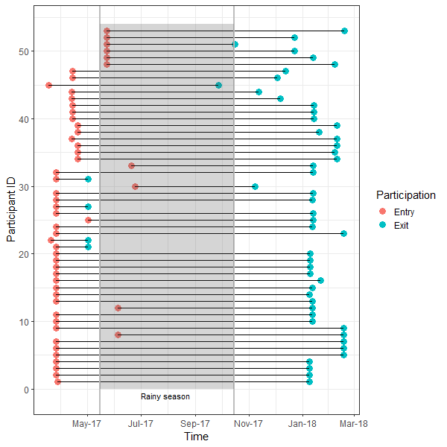

**Figure S3**: Duration of participation for each person, over the study period

**Figure S4**: Frequency histogram of maximum Euclidian distance travelled by the participants in kilometres

**Figure S5**: Multiday trips made by the participants

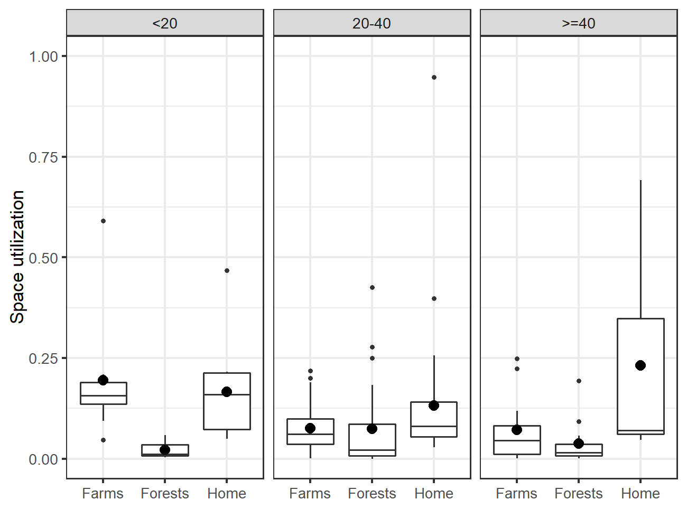

**Figure S6**: Utilization of the farm, forest, and home (estimated through a biased-random bridge (BRB) algorithm) over the participation period for different age groups. The bigger dots represent the mean values, while the smaller dots represent the outliers. Usage of Home was underestimated because of the limitation explained in the Methods section.